

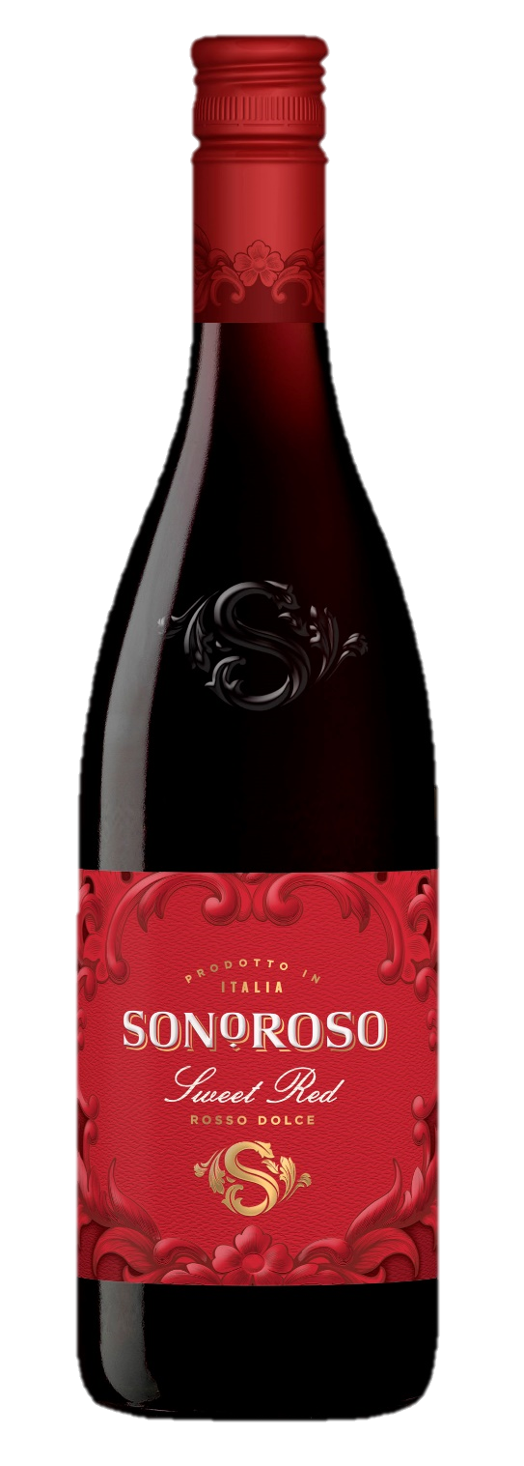

|  |  |
| --- | --- |
| COUNTRY | Italy |
| REGION | Trentino |
| APPELLATION | Trevenezie IGT |
| VARIETALS | Teroldego, Marzemino, Merlot |
| FORMAT + NOTES | 750ml, Screw Cap, Gluten Free, Vegan |

**Vinification**

Each varietal is manually harvested at the perfect ripeness to preserve aromas and freshness. Following de-stemming, the juice is kept in contact with the grape skin for several days at low temperatures (cold maceration) to extract the fruit’s aroma and color. Then a partial fermentation is done at low temperature to preserve the natural sweetness, the fruity character and the fizzy style.

**Color**

Brilliant ruby red

**AROMA**

Delicate scents of plum and violet compliment the aromas of red fruits and sweet spice.

**FLAVOR**

Fresh, vibrant and slightly *frizzante* with notes of blackberry and cherry for a sensuous taste, finishing with a touch of sweetness.

**Analysis**

Alcohol: 7 % Residual Sugar: 10 g/l Total Acidity: 5.30g/l

**Serving Suggestions**

Pleasantly refreshing and food-friendly; pairs well with flavorful dishes and spicy cuisine, or even your favorite dessert! Serve chilled.

***Rosso Dolce* Sweet Red**

A new Italian story to tell… Meet **Sonoroso**, the sweet reminder of Italy with a savory ending. **Sonoroso** is *your new sweet thing*! **Sonoroso** is an irresistible, delicately sweet line of wines from northern Italy. It makes a wonderful aperitif and is also incredibly food-friendly with a variety of dishes.

**Sonoroso** combines traditional growing practices with a modern flair in winemaking and style. The wines are rich and enticing – and eager to please with their ease of taste and enjoyment. With a lower alcohol of 7% and a hint of sparkle that balances a delicate burst of fruit, **Sonoroso** is *your sweet thing* that is the ideal complement for classic Italian dishes but also spicy Asian or barbeque, and more.